Standing Together for the Earth
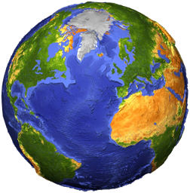
Last month people around the globe celebrated Earth Day. You can read more about it here:

https://www.earthday.org/earth-day-2020/

Because millions of people have had to stay inside a lot more than normal during the current lockdown, the animals have been out and about – and the world is beginning to look a bit different.

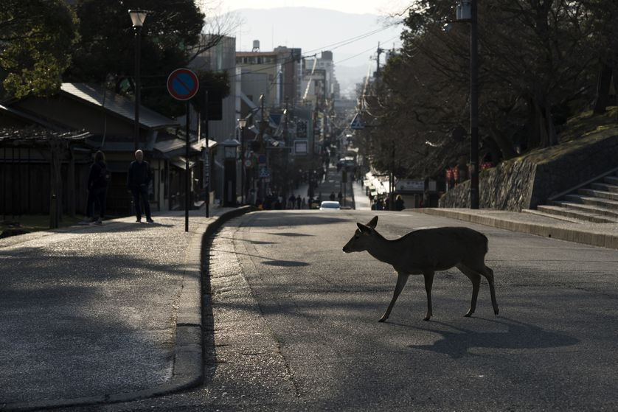
Look at this deer crossing a city road in Japan.
Would the deer be able to do this if it wasn’t for the lockdown? Why not?
What do think it is doing in the middle of a city?
What might it be looking for?

Lockdowns that have kept millions of people in their homes around the world have resulted in clearer skies, quieter streets and more peaceful oceans.
These are challenging times for human beings, but for many of Earth's other inhabitants, it’s been good news.
Animals are feeling braver and are beginning to show up in different places. Whales have travelled further up an estuary in Vancouver than every before and, thanks to the absence of cruise ships, dolphins have returned in greater numbers to the Italian port of Cagliari. Sheep have been playing in parks in Wales and the bears and other animals of Yosemite National Park in California have been having a "party" since the park closed on March 20. There are typically so many humans and cars at this time of year that the bears have to pick their paths carefully to avoid them, but that’s not the case now. Bears are literally walking down the road to get to where they need to go, which is kind of cool.
Wildlife in some of the world's most human-populated places is taking advantage of the empty streets by running... well…wild. As towns and cities across the planet remain on lockdown, animals are making the most of life without the crowds. People first saw the unusual goings-on in the UK last week, when a herd of mountain goats descended on the Welsh seaside town of Llandudno.
Elsewhere, people out food shopping in Paris have watched as ducks cross the usually busy streets. Venice, which is used to motorboat traffic bringing in lots of tourists, now has clear waters – and seabirds are enjoying leisurely swims.
Meanwhile, rabbits have taken to the streets in the city of Christchurch in New Zealand and elegant peacocks have been spotted seemingly browsing the shop windows in Dubai!

Take a look at the photos of wildlife feeling happy and confident in towns and cities around the world...... think about what God would make of his world at this moment.

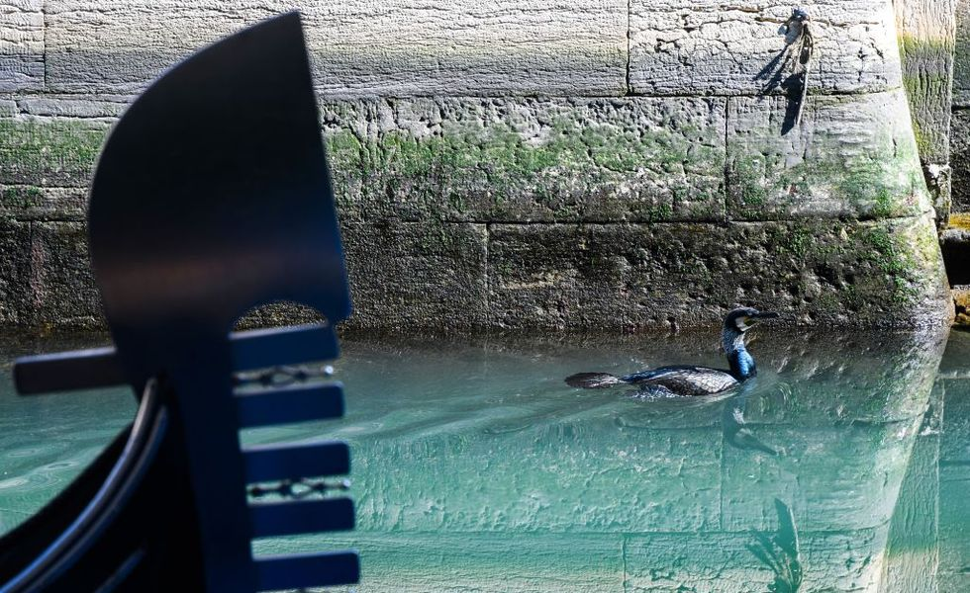
This seabird was pictured swimming across clear waters next to a parked gondola on a Venice canal, on 17th March. As a result of decreased motorboat traffic, the city's famous canals have welcomed new life.

.

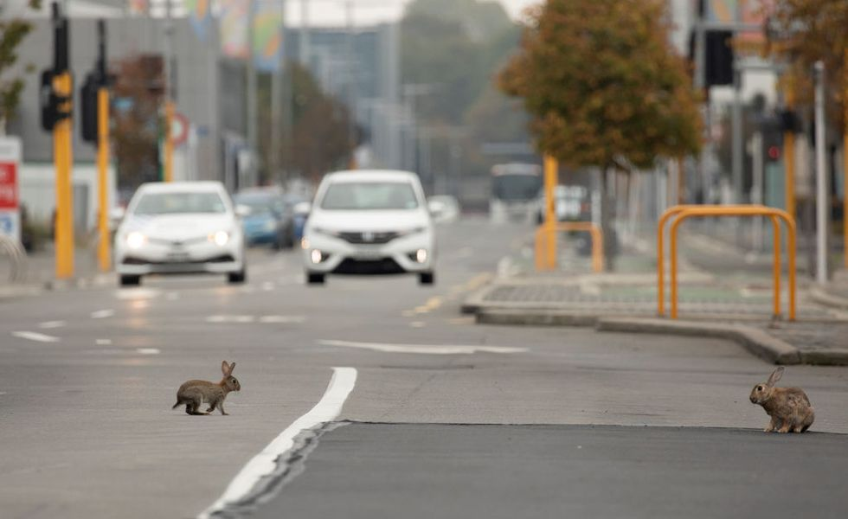
These rabbits crossed a main road in Christchurch on 1st April, during lockdown in New Zealand

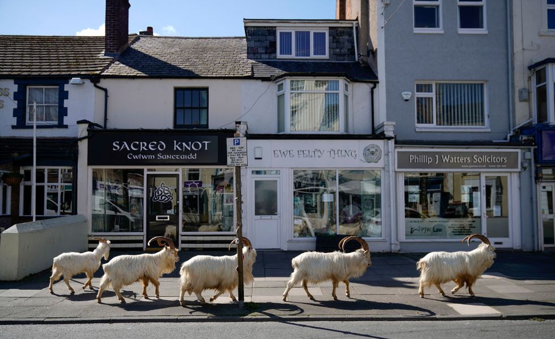

The goats of the Welsh seaside spot, Llandudno, normally live on the rocky Great Orme but, on 31st March, the herd was drawn into the quiet town.

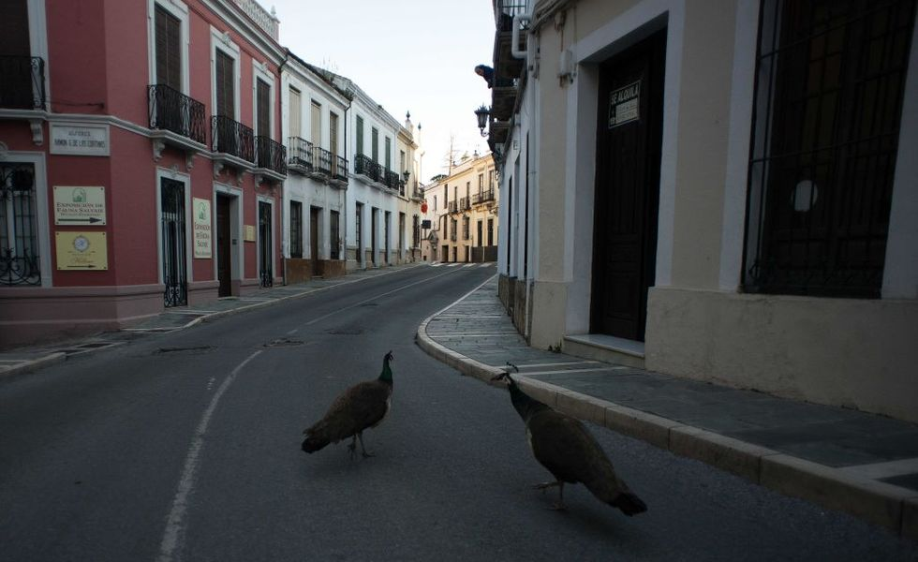
Two peacocks walked down a street in the Spanish city of Ronda on 3rd April, during the national lockdown.

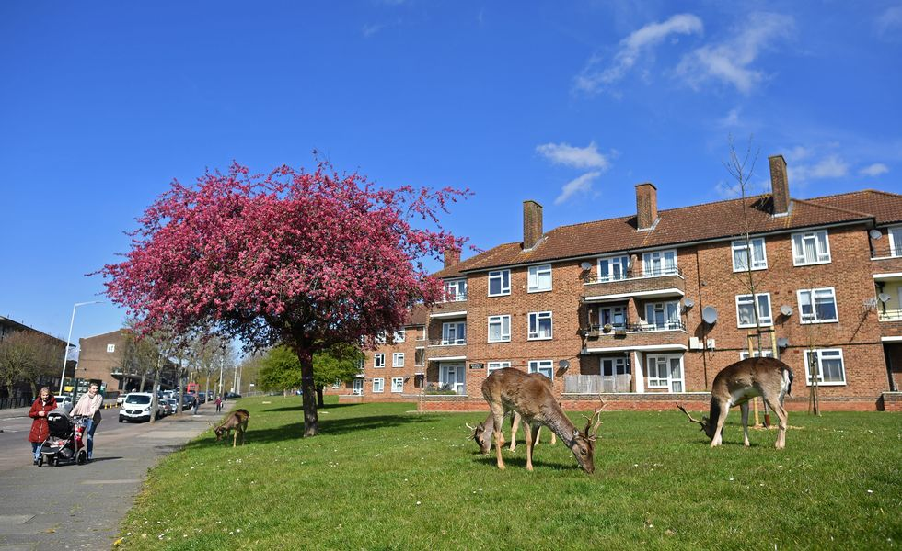

People passed a herd of deer grazing on the lawns of a housing estate in east London on 4th April, as nature took advantage of life in Britain during the nationwide lockdown.

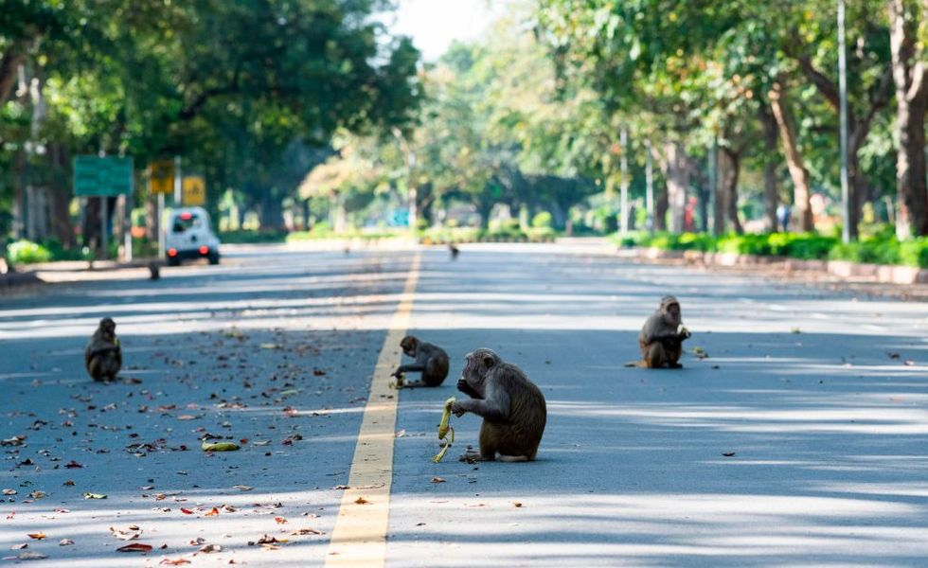
Monkeys were pictured eating bananas in a deserted street during the government-imposed lockdown in India's capital, New Delhi, on 2nd April.

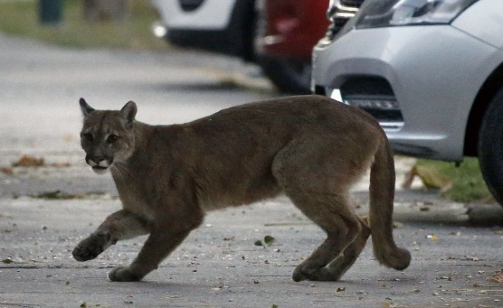
A puma ventured onto the streets of Chile's capital Santiago on 24th March which came down from the nearby mountains in search of food while fewer people were on the streets.

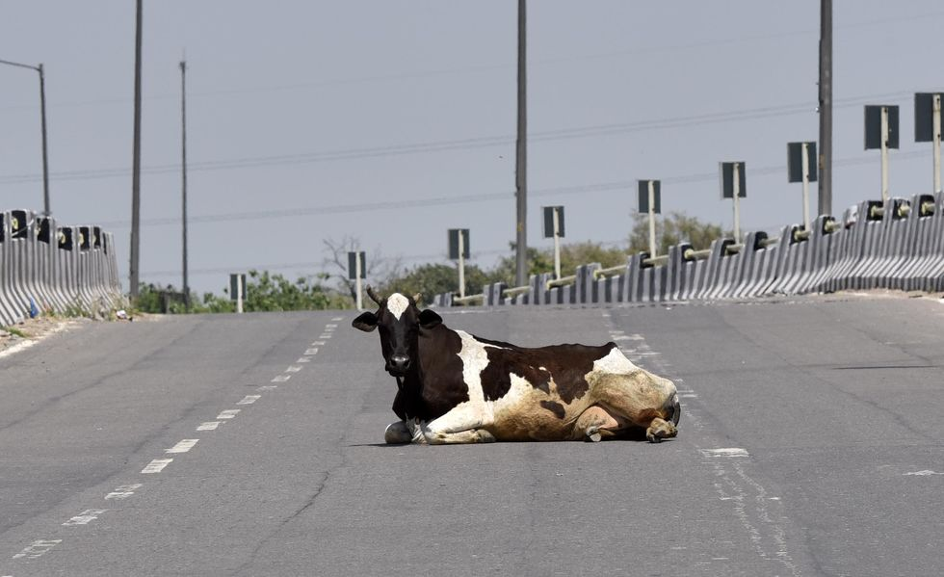
This cow was pictured sitting in the middle of the road on a deserted flyover near Timarpur, Delhi on 4th April, the 11th day of the nationwide lockdown in India.

The peace of cities and towns and may not only benefit animals. Humans too may soon appear from their homes with a new understanding of their relationship with the natural world. Perhaps people will understand that they can do more to protect the Earth when they stand together.

The Creation story - What does God want us to do?
Christians believe that God cares for the world and that God wants us to care for it too. Look at what the Bible says:

And God said, "See, to you I give every plant which grows on all the earth, and every tree which bears fruit with its own kind of seed. It shall be food for you. And to every wild beast and to every bird of the sky and to every thing that crawls on the earth and is alive, I give every green herb for food." And it was done.

Questions:
- What do you like in God’s creation?
- How well do you think that we take care of God’s world normally?
- How do you think God feels when he sees the animals in the world’s quieter cities and oceans at the moment?
- When the earth gets spoilt, do you think that God is happy or sad?

Write down three things that you would like to change to improve the natural world from what you have learnt during the lockdown.
1.
2.
3.

Here are some activities that you might like to do to celebrate our wonderful world.

Rubbish tubes & green ladders
(like snakes & ladders)

1. Using a ruler, draw a large grid with 100 squares (10 x 10).

2. Number each square consecutively from 1-100. Start in the bottom left hand corner and work along one row, up one column and back along the next row (like a snakes and ladders board).

3. Think of 10 good things to do with the environment such as: recycle bottles, put bird food in the garden, put used gum in the bin, compost waste vegetables, go shopping with a bag, buy recycled paper, walk to church instead of driving, plant shrubs with berries for birds.
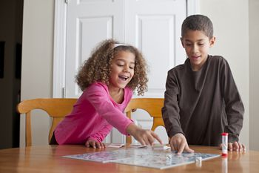
4. Think of 10 bad things to do with the environment such as: stick gum under chairs, use a car for a short journey, throw cans and glass bottles away, throw sweet papers on the pavement, turn the heating up to maximum, leave lights on in rooms not being used.

5. Write the bad things on squares and draw a tube leading downwards.

6. Write the good things on squares and draw a green ladder leading upwards.

7. Colour the pictures and squares.

8. Write ‘Start’ on square number 1 and ‘Green Citizen Award’ on square 100. Start the game by rolling a dice!

Go on a minibeast hunt
Spring is well and truly kicking in now, and the warmer weather will bring lots of creepy crawlies out. So get out in the fresh air and take a closer look at your garden. You'll soon notice it's teeming with wildlife! Can you find...
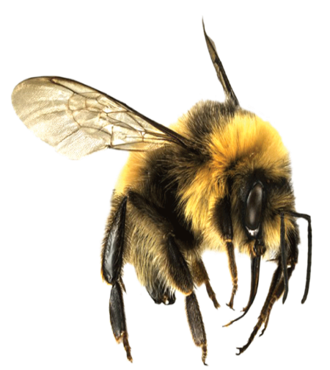
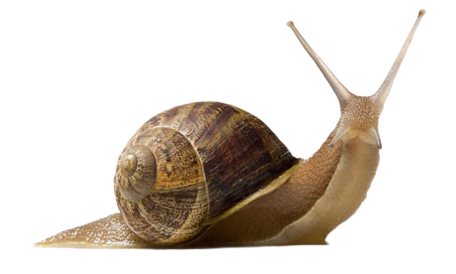
- a worm after a spring shower
- a bumblebee looking for nectar
- a spotty ladybird exploring the grass
- a slimy snail in a dark damp spot
- a butterfly basking in the sunshine?

Make a loo roll bird feeder
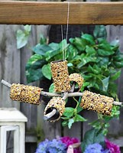
You can make this simple feeder with items you probably already have at home:
- Smother a cardboard tube in peanut butter or normal butter (no added salt and sugar versions are best for birds).
- Roll it in bird seed and thread some string through the hole.
- Tie it up in your garden where birds will feel safe eating. How many garden birds will you spot? Take a look at this blog to help you identify them.

Nature Detectives Game
Challenge someone in your house to complete a ‘scavenger hunt’ to find out who is the best become a nature detective.
A scavenger hunt is a game in which everyone gets a list of things to find in a certain amount of time. The more things you find, the more points you get!
They are also a great way to add fun to a daily exercise walk.
Get some ideas from the themes below and use them to make your own scavenger hunt lists.

Spring scavenger hunt
In spring, nature starts to wake up from its long winter sleep. Trees burst into leaf, flowers cover the ground and animals emerge from hibernation. There’s so much to see, can you find…
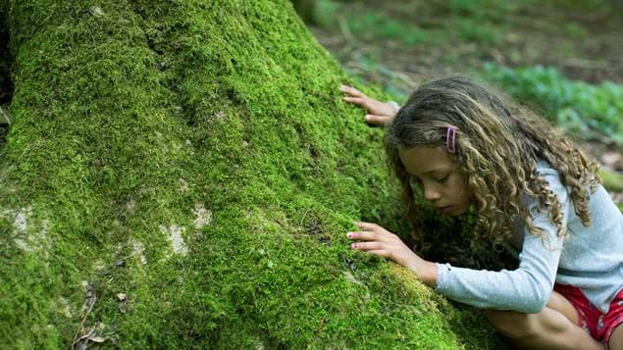
- new green leaves
- scented blossom
- springy moss
- sticky leaf buds
- a lichen-covered twig
- a piece of eggshell (stay well away from bird nests, look for fragments of shell that have fallen to the ground)

Tiny treasure hunt
You’ll need to keep your eyes peeled for this activity. Hunt for really small things you can fit into a matchbox. Collect little leaves, blades of grass, small snail shells, tiny twigs, feathers and pebbles. Turn it into a competition with your family – who can fit the most items inside their box?
If you have one, you can take a magnifying glass on your scavenger hunt to help investigate what you find. Can they see different patterns, changes in colours and interesting textures?
What teeny tiny woodland treasures will you collect?

Colour scavenger hunt
Ask game players to find different colours in nature. A red ladybird, blue sky, green grass, a yellow flower petal…

Texture scavenger hunt
Have a go at exploring with your other senses, such as touch. Can you find…
- smooth stones
- furry catkins
- rough bark
- a tickly feather
- spongy moss
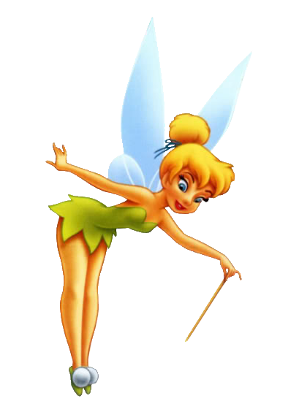
Imagination-based scavenger hunts
Let your imagination run wild and hunt for make-believe items. If you love playing pirates, look out for shipwrecks (fallen trees), cannon balls (conkers), parrot feathers (any feather), and an X marking the spot of buried treasure (crossed fallen twigs).
If you like fairies, look for evidence of elves and fairies in the woods. Can you find secret doorways in trees, toadstool seats, flower petal hats or acorn cup goblets?

Rice Krispie Earth Recipe

1/4 cup margarine
40 regular marshmallows
1/2 tsp. vanilla essence (if you have any)
6 cups rice krispies
green and blue food coloring

Melt the margarine and marshmallows over medium heat in a large pot, stir in the vanilla essence and rice krispies.
Divide into two bowls
Add green food coloring to one bowl and blue food coloring to the second and stir till the cereal is fully coated
Take a scoop from the blue bowl and a scoop from the green bowl and mash them together into a ball (the earth), Don’t mix them too much or the colours will start to run into each other and you will not see your land and sea.
Set the balls aside until completely cool before you taste them

