STAR OF THE WEEK SEPTEMBER 11TH

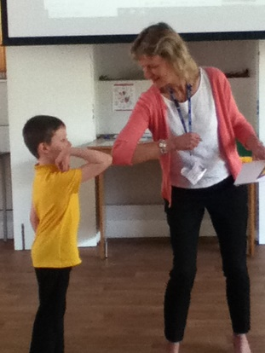
Oak Class– Jasmine
Apple Class – Charlie and Danny
Willow Class – Janis
Ash Class – William
Sycamore Class – Paige
Beech Class - Layla

